Final Review

$$v_{f}=at+v_{o}$$

$$∆x=\frac{1}{2}at^{2}+v_{o}t$$

$$v_{f}^{2}-v_{o}^{2}=2a∆x$$

$$F_{net}=ma$$

1. Write down the 3 kinematic equations and Newton’s 2nd Law on the top of this (or every) page.
2. Some baseball pitchers are capable of throwing a fastball at 100 mi/hr. The pitcher achieves this speed by moving his arm through a distance of 1.5 m. What is the acceleration of the ball? Determine the average net force that must be exerted on the 0.15 kg ball during the pitch.

$$v_{f}^{2}-v_{o}^{2}=2a∆x$$

$$(44.4\frac{m}{s})^{2}-{\left(0\frac{m}{s}\right)}^{2}=2a(1.5 m)$$

$$1975 \frac{m^{2}}{s^{2}}=\left(3m\right)a$$

$$a=658\frac{m}{s^{2}}$$

(1 mile = 1600 meters)

|  |  |  |
| --- | --- | --- |
| Fnet  Fnet  Fnet | =  =  = | ma  (0.15kg)(658m/s2)  98.7 N |

vo = 0 m/s

vf = 44.4 m/s

Δx = 1.5 m

a = ?

1. A racecar of mass 710 kg starts from rest and travels 40 meters in 3 seconds. How much does the car accelerate in this time? What is its final velocity? Draw an FBD and calculate the force due to friction that causes the car to move forward.

|  |  |  |
| --- | --- | --- |
| Fnet  Ffr  Ffr | =  =  = | ma  (710kg)(8.9 m/s2)  6311 N |

FN = 7100 N

$$v_{f}=at+v_{o}$$

$$v_{f}=\left(8.9\frac{m}{s^{2}}\right)\left(3s\right)+(0\frac{m}{s})$$

$$v_{f}=26.7\frac{m}{s}$$

$$∆x=\frac{1}{2}at^{2}+v_{o}t$$

$$40m=\frac{1}{2}a(3s)^{2}+(0\frac{m}{s})(3s)$$

$$40m=\left(4.5s^{2}\right)a$$

$$a=8.9\frac{m}{s^{2}}$$

vo = 0 m/s

Δx = 40 m

t = 3s

a = ?

vf = ?

Ffr = ?

Fg = 7100 N

1. A 2000 kg car slows down from 20 m/s to 5 m/s in 4 seconds. What is the net force acting on the car? How far did the car travel while it slowed down?

|  |  |  |
| --- | --- | --- |
| Fnet  Ffr  Ffr | =  =  = | ma  (2000kg)(-3.75 m/s2)  7500 N |

vo = 20 m/s  
vf = 5 m/s

t = 4s

a = ?

Δx = ?

1. A football player hits a 75 kg training dummy with 200 N of force. The frictional force on the dummy is 150 N. Draw an FBD of the dummy and calculate all the forces acting on it. What is the acceleration of the dummy? If the player maintains his 200 N force for 5 seconds, how fast will the dummy be travelling (assuming it started from rest)?

|  |  |  |
| --- | --- | --- |
| Fnet  FN – Ffr  200 N – 150 N  50 N  a | =  =  =  =  = | ma  (75kg)a  (75kg)a  (75kg)a  0.7 m/s2 |

Fg = 750 N

FN = 750 N



a = 0.7 m/s2

t = 5s

vo = 0 m/s  
vf = ?

FN = 200 N

Ffr = 150 N

1. A 1000 kg car travels at 25 m/s (55 mph) down a level road when (oh no!) the driver spots a deer 60m away. The driver slams on the brakes immediately.
   1. Draw an FBD of a car slamming to a stop. If its brakes can apply a maximum of 5000 N of force, what is its acceleration?

|  |  |  |
| --- | --- | --- |
| Fnet  – Ffr  – 5000 N  a | =  =  =  = | ma  (1000kg)a  (1000kg)a  -5 m/s2 |

FN = 10000 N

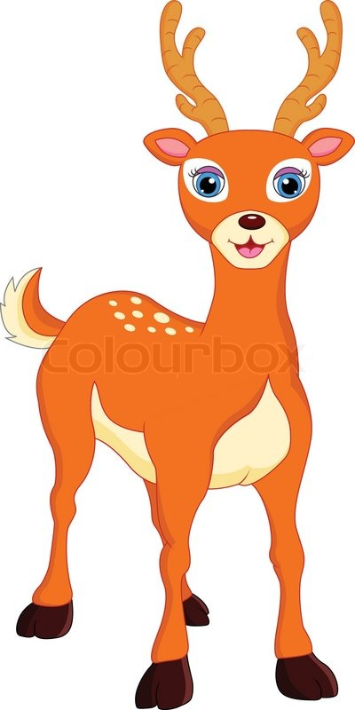

Ffr = 5000 N

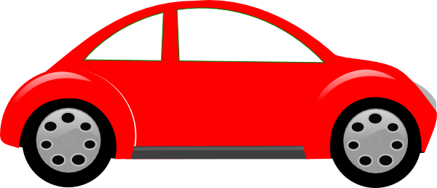

Fg = 10000 N

* 1. What is the minimum distance required for the car to stop?

$$v_{f}^{2}-v_{o}^{2}=2a∆x$$

$∆x=$ 62.5 m

a = -5 m/s2

vo = 25 m/s  
vf = 0 m/s

Δx = ?

* 1. How long does it take for the car to stop?

$$v_{f}=at+v_{o}$$

$$t=5 s$$

|  |  |  |  |  |
| --- | --- | --- | --- | --- |
|  |  |  |  |  |
|  |  |  |  |  |
|  |  |  |  |  |
|  |  |  |  |  |
|  |  |  |  |  |
|  |  |  |  |  |
|  |  |  |  |  |
|  |  |  |  |  |
|  |  |  |  |  |
|  |  |  |  |  |
|  |  |  |  |  |
|  |  |  |  |  |
|  |  |  |  |  |

0 1 2 3 4 5 t (s)

x (m)

65

60

55

50

45

40

35

30

25

20

15

10

5

* 1. Graph its position, velocity, and acceleration. Draw a motion map.

v (m/s)

25

20

15

10

5

0

-5

-10

-15

|  |  |  |  |  |
| --- | --- | --- | --- | --- |
|  |  |  |  |  |
|  |  |  |  |  |
|  |  |  |  |  |
|  |  |  |  |  |
|  |  |  |  |  |
|  |  |  |  |  |
|  |  |  |  |  |
|  |  |  |  |  |

1 2 3 4 5 t (s)

a (m/s2)

8

6

4

2

0

-2

-4

-6

-8

|  |  |  |  |  |
| --- | --- | --- | --- | --- |
|  |  |  |  |  |
|  |  |  |  |  |
|  |  |  |  |  |
|  |  |  |  |  |
|  |  |  |  |  |
|  |  |  |  |  |
|  |  |  |  |  |
|  |  |  |  |  |

1 2 3 4 5 t (s)

0m 5 10 15 20 25 30 35 40 45 50 55 60 65

|  |  |  |  |  |  |  |  |  |  |  |  |  |
| --- | --- | --- | --- | --- | --- | --- | --- | --- | --- | --- | --- | --- |
|  |  |  |  |  |  |  |  |  |  |  |  |  |

1. Your siblings are not pleased with moving at a constant velocity. They demand you to pull them harder than your lazy and minimal effort. The cord makes a 25° angle with the horizontal. The mass of the sled and your siblings combined is 100 kg. You pull the cord with a force of 110 N and 25 N of frictional force resist the motion of the sled.
   1. Draw an FBD of the sled and calculate its acceleration.

|  |  |  |
| --- | --- | --- |
| Fnet  FTx – Ffr  100N – 25 N  a | =  =  =  = | ma  (100kg)a  (100kg)a  0.75 m/s2 |

FT = 110 N

FN = ?

25°



Ffr = 25N

Fg = 1000 N

* 1. You initially were moving at 0.25 m/s. How fast were you moving after 3 seconds of pulling with 110 N? How far did you travel?

a = 0.75 m/s2

vo = 0.25 m/s

t = 3s  
vf = ?

Δx = ?

4.125 m

* 1. After pulling them for those 3 seconds, you reached your max strength and let go of the sled. What is its acceleration as it slows down?

|  |  |  |
| --- | --- | --- |
| Fnet  – Ffr  – 25 N  a | =  =  =  = | ma  (100kg)a  (100kg)a  -0.25 m/s2 |

a = -0.25 m/s2

vo = 2.5 m/s

vf = 0 m/s

Δx = ?

t = ?

* 1. How far will your siblings go before stopping? How long will it take for them to stop?

12.5 m

* 1. Graph the position, velocity, and acceleration of the entire scenario. Draw a motion map.

|  |  |  |  |  |  |  |  |
| --- | --- | --- | --- | --- | --- | --- | --- |
|  |  |  |  |  |  |  |  |
|  |  |  |  |  |  |  |  |
|  |  |  |  |  |  |  |  |
|  |  |  |  |  |  |  |  |
|  |  |  |  |  |  |  |  |
|  |  |  |  |  |  |  |  |
|  |  |  |  |  |  |  |  |

2 4 6 8 10 12 14 16 t (s)

v (m/s)

5

4

3

2

1

0

-1

-2

|  |  |  |  |  |  |  |  |
| --- | --- | --- | --- | --- | --- | --- | --- |
|  |  |  |  |  |  |  |  |
|  |  |  |  |  |  |  |  |
|  |  |  |  |  |  |  |  |
|  |  |  |  |  |  |  |  |
|  |  |  |  |  |  |  |  |
|  |  |  |  |  |  |  |  |
|  |  |  |  |  |  |  |  |
|  |  |  |  |  |  |  |  |
|  |  |  |  |  |  |  |  |

0 2 4 6 8 10 12 14 16 t (s)

x (m)

18

16

14

12

10

8

6

4

2

|  |  |  |  |  |  |  |  |
| --- | --- | --- | --- | --- | --- | --- | --- |
|  |  |  |  |  |  |  |  |
|  |  |  |  |  |  |  |  |
|  |  |  |  |  |  |  |  |
|  |  |  |  |  |  |  |  |

2 4 6 8 10 12 14 16 t (s)

a (m/s2)

1

0.5

0

-0.5

-2

0m 2 4 6 8 10 12 14 16 18

|  |  |  |  |  |  |  |  |  |
| --- | --- | --- | --- | --- | --- | --- | --- | --- |
|  |  |  |  |  |  |  |  |  |

Picture solutions are difficult to draw on a computer. Sorry ☹

1. 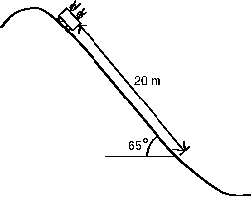A rollercoaster car, of mass 300 kg with passengers, accelerates down a 65° hill. The frictional force acting on the roller coaster car is 1519 N. Draw a force diagram for the system of car and riders.
   1. What is the acceleration of the roller coaster?

a = 4 m/s2

* 1. If they are traveling 4 m/s at the time shown in the picture, how fast will they be traveling at the end of the straight stretch, 20 m later? How long did it take for them to move 20m down the hill?

vf = 13.3 m/s

t = 2.3 s

a = 4 m/s2

vo = 4 m/s

Δx = 20 m

vf = ?

t = ?

* 1. The track levels out and friction slows the cart to a stop. How long does the track have to be for the cart to stop on its own? How long will it take to stop?

Δx = 17.6 m

t = 2.7 s

a = -5 m/s2

vo = 13.3 m/s

vf = 0 m/s

Δx = ?

t = ?

* 1. Graph the position, velocity, and acceleration of the entire scenario. Draw a motion map.

|  |  |  |  |  |  |  |  |  |  |
| --- | --- | --- | --- | --- | --- | --- | --- | --- | --- |
|  |  |  |  |  |  |  |  |  |  |
|  |  |  |  |  |  |  |  |  |  |
|  |  |  |  |  |  |  |  |  |  |
|  |  |  |  |  |  |  |  |  |  |
|  |  |  |  |  |  |  |  |  |  |
|  |  |  |  |  |  |  |  |  |  |
|  |  |  |  |  |  |  |  |  |  |
|  |  |  |  |  |  |  |  |  |  |

0 0.5 1 1.5 2 2.5 3 3.5 4 4.5 5 t (s)

x (m)

40

35

30

25

20

15

10

5

|  |  |  |  |  |  |  |  |  |  |
| --- | --- | --- | --- | --- | --- | --- | --- | --- | --- |
|  |  |  |  |  |  |  |  |  |  |
|  |  |  |  |  |  |  |  |  |  |
|  |  |  |  |  |  |  |  |  |  |
|  |  |  |  |  |  |  |  |  |  |
|  |  |  |  |  |  |  |  |  |  |
|  |  |  |  |  |  |  |  |  |  |
|  |  |  |  |  |  |  |  |  |  |

0.5 1 1.5 2 2.5 3 3.5 4 4.5 5 t (s)

v (m/s)

14

12

10

8

6

4

2

0

|  |  |  |  |  |  |  |  |  |  |
| --- | --- | --- | --- | --- | --- | --- | --- | --- | --- |
|  |  |  |  |  |  |  |  |  |  |
|  |  |  |  |  |  |  |  |  |  |
|  |  |  |  |  |  |  |  |  |  |
|  |  |  |  |  |  |  |  |  |  |
|  |  |  |  |  |  |  |  |  |  |
|  |  |  |  |  |  |  |  |  |  |

0.5 1 1.5 2 2.5 3 3.5 4 4.5 5 t (s)

a (m/s2)

6

4

2

0

-2

-4

-6

0m 4 8 12 16 20 24 28 32 36 40

|  |  |  |  |  |  |  |  |  |  |
| --- | --- | --- | --- | --- | --- | --- | --- | --- | --- |
|  |  |  |  |  |  |  |  |  |  |

Picture solutions are difficult to draw on a computer. Sorry ☹