Newton’s Second Law

1. Write Newton’s Second Law on the top of this page.
2. An 80 kg water skier is being pulled by a boat with a force of 200 N causing the skier to accelerate at 1.8 m/s2. Find the drag force on the skier.

|  |  |  |
| --- | --- | --- |
| Fnet  Fnet  Fnet  FT – Fdrag  200 N - Fdrag  -Fdrag  Fdrag | =  =  =  =  =  =  = | ma  (80kg)(1.8m/s2)  144 N  144 N  144 N  -56 N  56 N |

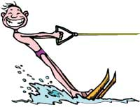

Fdrag = ?

FT = 200 N

Fbuoyant = 800 N

Fg = 800 N

1. A 4600 kg helicopter accelerates upward at 2.0 m/s2. Draw an FBD of the rising helicopter. Determine the lift force exerted on the propellers by the air.

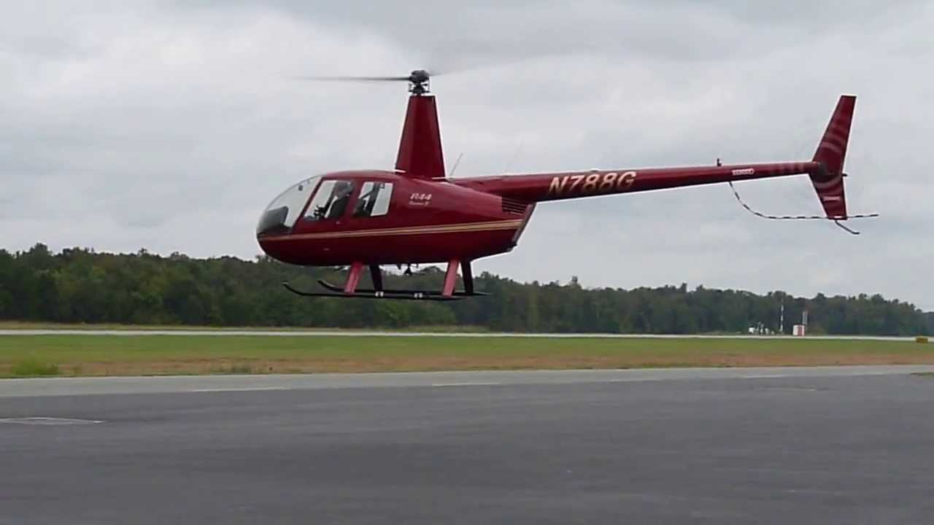

Flift = ?

|  |  |  |
| --- | --- | --- |
| Fnet  Fnet  Fnet  Flift – Fg  Flift – 46000 N  Flift | =  =  =  =  =  = | ma  (4600kg)(2m/s2)  9200 N  9200 N  9200 N  55200 N |

Fg = 46000 N

1. The maximum force a grocery bag can withstand without ripping is 250 N. Suppose that the bag is filled with 20 kg of groceries and is lifted with an acceleration of 5.0 m/s2. Draw an FBD of the bag. Will the groceries stay in the bag?



|  |  |  |
| --- | --- | --- |
| Fnet  Fnet  Fnet  FT – Fg  FT – 200 N  FT | =  =  =  =  =  = | ma  (20kg)(5m/s2)  100 N  100 N  100 N  300 N |

FT = ?

Fg = 200 N

No, you pulled with 300 N and it can only handle 250 N so it will break.

1. a. A 70 kg skydiver jumps out of an airplane. Immediately after jumping, how large is the skydiver’s acceleration? (Hint: only one force is acting on the skydiver)

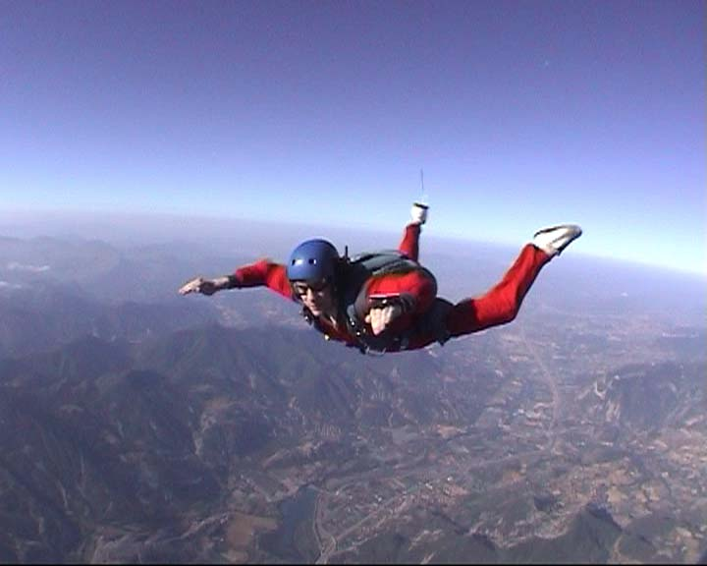

|  |  |  |
| --- | --- | --- |
| Fnet  Fnet  Fg  -700 N  a  a | =  =  =  =  =  = | ma  (70kg)a  (70kg)a  (70kg)a  -10N/kg OR  -10m/s2  (ahem, ag = -9.81m/s2) |

Fg = 700 N

b. After reaching a speed of 100mph, 300 N of drag resist the diver’s motion. Draw an FBD of the diver. What is her acceleration now?

Fdrag = 300 N

|  |  |  |
| --- | --- | --- |
| Fnet  Fnet  Fdrag - Fg  300 N – 700 N  – 400 N  a | =  =  =  =  =  = | ma  (70kg)a  (70kg)a  (70kg)a  (70kg)a  -5.7m/s2 |

Fg = 700 N

1. Draw an FBD for a 900 kg car that exerts 5000 N of frictional force on a level road to move forward, while being opposed by 1000 N of drag force. What is the acceleration of the car?

|  |  |  |
| --- | --- | --- |
| Fnet  Ffr - Fdrag  5000 N – 1000 N  4000 N  a | =  =  =  =  = | ma  (900kg)a  (900kg)a  (900kg)a  4.4 m/s2 |

Ffr = 5000 N

Fg = 9000 N

FN = 9000 N

Fdrag = 1000 N

1. a. A 50 kg classmate is resting on a level tile floor. You push her with 100 N. The force due to friction on her is 75N. Draw an FBD of your classmate. What is her acceleration?

|  |  |  |
| --- | --- | --- |
| Fnet  FN – Ffr  100 N – 75 N  25N  a | =  =  =  =  = | ma  (50kg)a  (50kg)a  (50kg)a  0.5 m/s2 |

FN = 500 N

Ffr = 75 N

FN = 100 N

Fg = 500 N

b. Suppose your classmate is on a carpet now, where the force due to friction is 125 N. Is your push sufficient to cause her to accelerate? Why or why not?

No, your force (100 N) is not greater than the friction. She will slow down.

1. A 70 kg box if pulled by a 400 N force at an angle of 30° to the horizontal. The force due to friction is 75 N. Draw an FBD for the box and determine its acceleration.

$$\cos\left(30°\right)= \frac{F_{Tx}}{F_{T}}$$

$$\cos\left(30°\right)= \frac{F_{Tx}}{400 N}$$

$$F_{Tx}=346 N$$

$$\sin\left(30°\right)= \frac{F_{Ty}}{F_{T}}$$

$$\sin\left(30°\right)= \frac{F_{Ty}}{400 N}$$

$$F_{Ty}=200 N$$

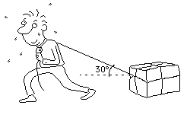

Fg = 700 N

FN = ?

(does not accelerate in the vertical)

|  |  |  |
| --- | --- | --- |
| Fnet y  FN + FTy - Fg  FN  F­N | =  =  =  = | ma  (70kg)(0m/s2)  700 N – 200 N  500 N |

FT = 400 N

|  |  |  |
| --- | --- | --- |
| Fnet x  Ffr – FTx  75 N – 346 N  -271N  a | =  =  =  =  = | ma  (70kg)a  (70kg)a  (70kg)a  -3.9 m/s2 |

Ffr = 75 N

30°

1. A worker pushes a 7 kg shipping box along a roller track. Assume friction is small enough to be ignored because of the rollers. The worker's push is 25 N directed down and to the right at an angle of 20°. Draw an FBD for the box and calculate the value of all the forces acting on the box. What is its acceleration?

**Ho hum…**

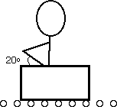

$$\cos\left(20°\right)= \frac{F_{Nx}}{F_{N}}$$

$$\cos\left(20°\right)= \frac{F_{Nx}}{25 N}$$

$$F_{Nx}=23.5 N$$

$$\sin\left(20°\right)= \frac{F_{Ny}}{F_{N}}$$

$$\sin\left(20°\right)= \frac{F_{Ny}}{25 N}$$

$$F_{Ny}=8.6 N$$

FN = ?

|  |  |  |
| --- | --- | --- |
| Fnet x  FNx  23.5  a | =  =  =  = | ma  (7kg)a  (7kg)a  3.4 m/s2 |

(does not accelerate in the vertical)

|  |  |  |
| --- | --- | --- |
| Fnet y  FN – FNy – Fg  FN  F­N | =  =  =  = | ma  (7kg)(0m/s2)  8.6 N + 70 N  78.6 N |

20°

FN = 25 N

Fg = 70 N

1. A child of mass 30 kg takes a trip down a slide. The frictional force is 160 N. Draw an FBD for the child and find his acceleration down the slide.

$$\cos\left(55°\right)= \frac{F_{gy}}{F_{g}}$$

$$\cos\left(55°\right)= \frac{F_{gy}}{300 N}$$

$$F_{gy}=172 N$$

$$\sin\left(55°\right)= \frac{F_{gx}}{F_{g}}$$

$$\sin\left(55°\right)= \frac{F_{gx}}{300 N}$$

$$F_{gx}=246 N$$

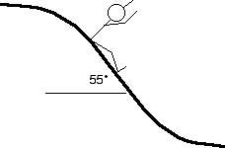

(does not accelerate in the vertical)

|  |  |  |
| --- | --- | --- |
| Fnet y  FN – Fgy  FN – Fgy  F­N  FN | =  =  =  =  = | ma  (30kg)(0m/s2)  0  Fgy  172 N |

Ffr = 160 N

|  |  |  |
| --- | --- | --- |
| Fnet x  Fgx - Ffr  246 N – 160 N  86 N  a | =  =  =  =  = | ma  (30kg)a  (30kg)a  (30kg)a  2.9 m/s2 |

FN = ?

55°

Fgy = ?

Fgx = ?

Fg = 300 N

1. The 60 kg skier shown below is skiing down a 35° incline with a frictional force of 40 N. Determine the acceleration of the skier.

$$\cos\left(35°\right)= \frac{F_{gy}}{F_{g}}$$

$$\cos\left(35°\right)= \frac{F_{gy}}{300 N}$$

$$F_{gy}=246 N$$

$$\sin\left(35°\right)= \frac{F_{gx}}{F_{g}}$$

$$\sin\left(35°\right)= \frac{F_{gx}}{600 N}$$

$$F_{gx}=344 N$$

(does not accelerate in the vertical)

|  |  |  |
| --- | --- | --- |
| Fnet y  FN – Fgy  FN – Fgy  F­N  FN | =  =  =  =  = | ma  (30kg)(0m/s2)  0  Fgy  246 N |



|  |  |  |
| --- | --- | --- |
| Fnet x  Fgx - Ffr  344 N – 40 N  304 N  a | =  =  =  =  = | ma  (60kg)a  (60kg)a  (60kg)a  5.1 m/s2 |

FN = ?

Ffr = 40 N

35°

Fgy = ?

Fgx = ?

Fg = 600 N